**OSH AUTHORITIES - MALTA**

Source: <https://oshwiki.eu/wiki/OSH_system_at_national_level_-_Malta>

* **OSH Infrastructure**

**Scheme**

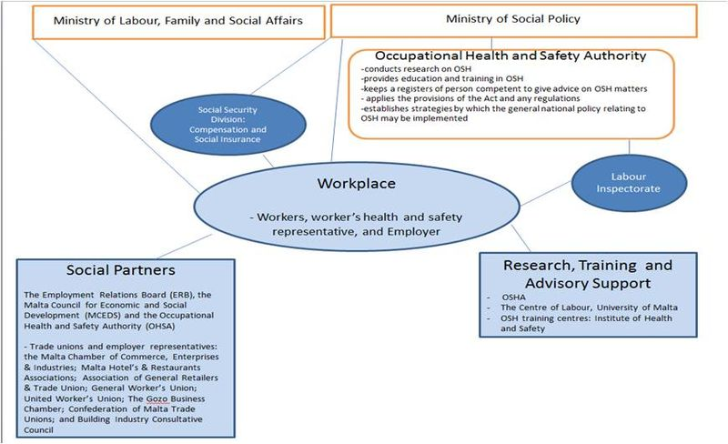

**Explanatory text**

|  |
| --- |
| The main stakeholders involved in relation to occupational health and safety in Malta are the Government, workers (& their representatives) and the employers (& their representatives). However, other stakeholders are involved – the media, politicians, the Church, Government as the largest employer in Malta, commercial services providers (including occupational health and safety training centres), importers & manufacturers of products / equipment used at work and civil society. |

* **OSH auth****orities and inspection services**

|  |  |
| --- | --- |
| Name of the Authority | Occupational Health and Safety Authority |
| Link | <http://www.ohsa.org.mt/> |
| Short abstract | The occupational safety and health national infrastructure is structured and influenced by the OHSA. The main aims and objectives of the Occupational Health and Safety Authority include raising awareness of health and safety as an issue in the workplace, providing information and promoting training on health and safety matters as well as consulting widely and effectively on health and safety regulations and guidance. The OHSA is responsible for the ensuring that the physical, psychological and social well-being of all Maltese workers in all workplaces is promoted; and, in turn, to ensure that workers health and safety is actively safeguarded, by whoever is obliged to do so, by ensuring that the levels of occupational health and safety protection (as established by the Act and by the regulations made under this Act) are maintained. Since Malta’s accession to the European Union, the OHS Authority has continued the exercise of harmonization of all new occupational health and safety legislation with EU OHS Directives, while at the same time reviewing existing legislation to ensure that there are no regulatory gaps, and to identify any conflicting or burdensome legislation, with the scope of simplifying it.  Among its various fuctions, the OHSA:  (1) applies the provisions of the Act and any regulations or orders made there under;  (2) establishes strategies by which the general national policy relating to occupational health and safety may be implemented; (3) advises the Minister regarding the making of regulations;  (4) monitors compliance with the relevant health and safety legislation;  (5) prepares regulations and codes of practice;  (6) promotes the dissemination of information, education and training;  (7) collates and analyses data and statistics;  (8) keeps registers of plants, installations, equipment, machinery, articles, substances or chemicals in use at work;  (9) carries out investigations on any matter concerning occupational health and safety;  (10) promotes and carries out scientific research; and  (11) keeps registers of persons competent to give advice on matters related to OHS.  As aforementiond, the OHSA is the national statutory body with responsibility for enforcing ocupational safety and health law, promoting and encouraging accident prevention, and providing infomation and advice to companies, organisations and individuals. The Authority considers enforcement as one of its key core functions – the purpose of enforcement is to ensure that duty holders effectively control risks at their place of work. Through the enactment of the Act (Act XXVII of 2000), a number of health and safety officers were appointed by the OHSA. These officers are deemed to be Public Officers under Criminal Code, and, thus, are protected by law whilst on duty. These inspection officers have a number of powers at law, including: to enter freely into any workplace (day or night) without any pervious notice; and to inspect any document the keeping of which which is prescribed by any OSH regulation; and to issue order to any person to preserve OHS. |
| Link to OSH wiki | <https://oshwiki.eu/wiki/OSH_system_at_national_level_-_Malta> |

Internal link to enforcement indicator by MS

* **Compensation and Insurance bodies**

|  |  |
| --- | --- |
| Name of the Body | Maltese Social Security Division - Injury Benefit/Industrial Disease |
| Link | <http://socialsecurity.gov.mt/en/Pages/default.aspx> |
| Short abstract | Malta has a social security system as part of its social welfare national scheme. An individual who suffers a personal injury caused by accident arising out of or in the course of his/her employment or self-occupation; or has developed an illness or disease as a result of their work envrionment may be entitled to compensation through the Maltese Social Security Division: entitled Injury Benefit/Industrial Diseas. In order to claim for this benefit the worker must complete a standard issued application form with a report of the incidence or illness. The claim form must be signed by a the treating doctor (indicating the nature and duration fo the injury/ disease and anticipated recovery period), and counter signed by the employer. Once a claim is received, the case is referred to a Medical panel, appointed by the Minister of Education, Employment and the Family. The role of this panel is to examine the claim from a medical prespective, and establish whether the injury/ disease is a consequence of the work environment.  All organisations in Malta require industrial accident insurance, which is in the hands of private insurers. The Association of Insurance Brokers (AIB) is an association of most of the major insurance brokers in Malta, and represents the interests of the insurance brokerage industry. The Association interacts actively on behalf of its members with other insurance bodies in Malta, such as the Malta Insurance Association and the Malta Insurance Managers Association. |
| Link to OSH wiki | <https://oshwiki.eu/wiki/OSH_system_at_national_level_-_Malta> |

* **Research institutes**

|  |  |
| --- | --- |
| Name of the institute | Occupational Health and Safety Authority |
| Link | <http://www.ohsa.org.mt/> |
| Short abstract | There are no specific institutes carrying out research in relation to occupational health and safety in Malta. However, the OHSA has conducted some recent research, which examines the prevalent occupational health and safety levels in Malta.  This research focused on the following areas:   * the delivery of statistics on occupational injuries, physical ill-health, occupational psychological ill-health; while determining the root causes of such injuries and ill-health at a macro level. * the generation of data regarding the level of access of workers to internal and external OHS services * and the calculation of costs of the prevailing risk levels of occcupational health and safety to the nation.   In addition, the Centre for Labour Studies (University of Malta) also conducts research broadly in the area of occupational health and safety. |
| Link to OSH wiki | <https://oshwiki.eu/wiki/OSH_system_at_national_level_-_Malta> |

* **Prevention Institutes**

|  |  |
| --- | --- |
| Name of the institute | Occupational Health and Safety Authority |
| Link | <http://www.ohsa.org.mt/> |
| Short abstract | Occupational Health and Safety Authority is the main organisation in relation to health and safety in Malta. It is part of the Ministry of Social Policy. |
| Link to OSH wiki | <https://oshwiki.eu/wiki/OSH_system_at_national_level_-_Malta> |

|  |  |
| --- | --- |
| Name of the institute | The Institute of Health & Safety (IHS) |
| Link | <https://ihs.com.mt/> |
| Short abstract | The Institute of Health & Safety (IHS) provides health & safety, environmental, and medical services to international corporate clients.IHS offer a comprehensive range of internationally-accredited professional training and consultancy services in our areas of expertise. In addition they offer a number of accredited health and safety courses. |
| Link to OSH wiki | <https://oshwiki.eu/wiki/OSH_system_at_national_level_-_Malta> |

* **Standardization Bodies**

|  |  |
| --- | --- |
| Name of the Body | The ‘’Malta Standard Authority’’ (Malta Competition and Consumer Affairs Authority) |
| Link | <http://mccaa.org.mt/> |
| Short abstract | The ‘’Malta Standard Authority’’ (Malta Competition and Consumer Affairs Authority) is the national organisation responsible for the development and publication of standards. The MSA is a government agency under the Office of the Prime Minister. The MSA represents Malta at the European Level, as a member of the European Standardization Committee and at the worldwide level as a member of the International Standardization Organization. |
| Link to OSH wiki | <https://oshwiki.eu/wiki/OSH_system_at_national_level_-_Malta> |